Sunday 12/6: Join us after the service for coffee in Fellowship Hall.
Tuesday 12/8: Food Pantry set-up, 9:30-11am; distribution 12-2pm.
Thursday 12/10: Confirmation, 3:30pm; Worship & Music Team mtg, 4pm; Church Council, 7pm.
Saturday 12/12: Congregational Meeting (Part 2), 12:00 – 4:00 pm. Everyone is welcome. Worship Service, 5:30pm.
Sunday 12/13: Worship, 9am. Newsletter items and Pastoral “Desirable Qualities” survey due. Last day to bring in socks for the homeless.
Monday 12/14: Call Committee Meeting, 7pm.

PARISH CONCERNS

Please keep in your daily prayers all people in need, including:
- All who are providing essential services during the pandemic, and all who
are affected by it.
- Vernon & Jane Johnson haven’t been feeling well and Jane has pneumonia.
Their address is: 5781 Old State Rd. Kirkland, IL 60146-8817.
- Ashley Wrobel who was recently diagnosed with MS.
- Jo Boehmer’s niece, Jackie will be having surgery soon. She is still recovering
from a severe fall she suffered in April.
- Our congregation for patience and God’s leading as we walk through the
Pastoral call process.
- Pray for our next Pastor that their heart will be stirred to come to FLC.
- All those who are not able to worship with us because they are in health
care facilities or homebound especially Ina Koehler, Nancy Bakanas and
George Vodden.
- All those who are suffering physical or mental illness, and their families,
caregivers, and medical teams.
- All pregnant women and the babies they are carrying.
- All elected leaders, police officers, first responders, and military personnel,
that they hear and receive God’s guidance and protection.
- Our church and its activities, and all Christian churches.
- Persecuted Christians throughout the world.
- The NALC, NALS, the Great River Mission District, all Christian churches,
and our partners in SC and PA.

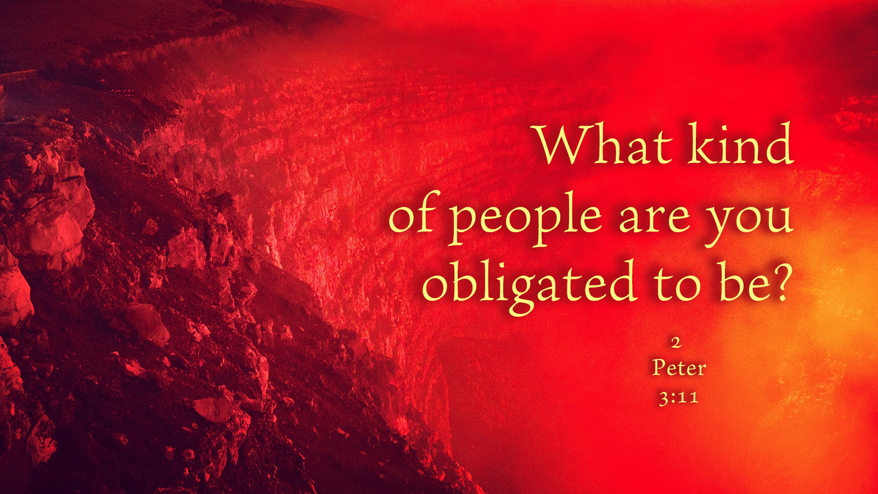

First Lutheran Church – Putting Christ First
Kirkland, IL – Est. December 26, 1873

Saturday, December 5, 2020
With readings for the 2nd Sunday of Advent

First Lutheran Church – Putting Christ First

December 5, 2020 – with readings for

The Second Sunday of Advent

A WARM WELCOME TO ALL who are worshiping with us today! We hope that the service will be a joy and blessing to you.

LBW – green hymnal WOV – navy hymnal

THE SERVICE BEGINS
P We begin this service IN THE NAME OF THE FATHER:
C Dear heavenly Father, you comforted your people with the promise that you would send us a savior;
P AND OF THE SON:
C Come Lord Jesus, the Son of God! Come in power and glory and victory! Come quickly, and save your people;
P AND OF THE HOLY SPIRIT:
C Come upon us, O Spirit of power and might. Breathe on us your life-giving breath, that we may watch and wait for Christ's return. Amen
SONG: “Prepare the Royal Highway” vv. 1 & 4 LBW 26
WE CONFESS
P With the words of Isaiah and the Psalms, we confess our sins and our grief, and we hear the comfort of the Lord.
C All people are grass, their constancy is like the flower of the field: the grass withers, the flower fades, when the breath of the Lord blows upon it; surely the people are grass. Isaiah 40
How shall we sing the Lord's song in a foreign land? If I forget you, O Jerusalem, let my right hand wither! Let my tongue cling to the roof of my mouth, if I do not remember you, if I do not set Jerusalem above my highest joy. Psalm 137
WE HEAR THE GOOD NEWS OF SALVATION
P The grass withers, the flower fades; but the word of our God will stand forever! Comfort, O comfort my people, says your God! Speak tenderly to Jerusalem, and cry unto her that her punishment is over, that her guilt is pardoned, that she has received from the Lord's hand double for all her sins. Behold, the Lord is coming to you. He will feed his flock like a shepherd, he will gather the lambs in his arms, and carry them in his bosom, and gently lead those that are with young. Isaiah 40
SHARING OF THE PEACE
PRAYER OF THE DAY

WHAT QUALITIES WOULD YOU LIKE TO SEE IN
OUR NEXT PASTOR?

There is a survey available on the Narthex bulletin board, please look over the questions in the newsletter and prayerfully select your top five desirable qualities. Please have them back into the office by Sunday, December 13th.

We all have been blessed and thankful to have had Pastor and Nancy Rasmussen for so many years. We will not find another Pastor exactly like him, but we must begin a new chapter with a new Pastor. Change isn’t easy, but God will lead us to our next Pastor.

SOCKS BOX
The Lydia Circle will begin collecting NEW, WHITE socks for men in need on Nov. 15th. Please bring the socks by December 13th and place them in the “SOCKS BOX” in the Narthex. The socks will then be taken to local shelters.

CHRISTMAS MEMORIAL GARDEN

Poinsettias for our Christmas Memorial Garden are ready to order. Only 17 plants are available, please order early. They are $9.00 each and order forms are in the narthex.

THURSDAY CONGREGATIONAL WORKSHOP SUMMARY

We had an informational, productive, and encouraging Congregational committee workshop on Thursday night. Pastor Lehmann led us in a Bible study, and we were able to discuss many of the questions on our congregational profile. It is important to remember that this process will take time.

As we have said all along, intensively, and purposefully PRAY!

We will have one more workshop to finish these questions on:

Saturday, December 12th from 12:00 - 4:00pm

After we complete our second workshop, the call committee will move forward and submit our congregational profile to the NALC.

If you cannot attend the meeting, you can email your answers to the questions printed in the newsletter to secretary@kirklandflc.org or drop them in the office. Thank you to everyone who attended the workshop, and we hope to see you on December 12th!
FIRST READING Isaiah 40:1-11
¹Comfort, comfort my people, says your God. ²Speak tenderly to Jerusalem, and cry to her that her warfare is ended, that her iniquity is pardoned, that she has received from the Lord’s hand double for all her sins. ³A voice cries: “In the wilderness prepare the way of the Lord; make straight in the desert a highway for our God. ⁴Every valley shall be lifted up, and every mountain and hill be made low; the uneven ground shall become level, and the rough places a plain. ⁵And the glory of the Lord shall be revealed, and all flesh shall see it together, for the mouth of the Lord has spoken.” ⁶A voice says, “Cry!” And I said, “What shall I cry?” All flesh is grass, and all its beauty is like the flower of the field. ⁷The grass withers, the flower fades when the breath of the Lord blows on it; surely the people are grass. ⁸The grass withers, the flower fades, but the word of our God will stand forever. ⁹Go on up to a high mountain, O Zion, herald of good news; lift up your voice with strength, O Jerusalem, herald of good news; lift it up, fear not; say to the cities of Judah, “Behold your God!” ¹⁰Behold, the Lord God comes with might, and his arm rules for him; behold, his reward is with him, and his recompense before him. ¹¹He will tend his flock like a shepherd; he will gather the lambs in his arms; he will carry them in his bosom, and gently lead those that are with young.
P The Word of the Lord. C Thanks be to God.

PSALM 85 (Read responsively by half verse) p. 254
SECOND READING 2 Peter 3:8-14
⁸Do not overlook this one fact, beloved, that with the Lord one day is as a thousand years, and a thousand years as one day. ⁹The Lord is not slow to fulfill his promise as some count slowness, but is patient toward you, not wishing that any should perish, but that all should reach repentance. ¹⁰But the day of the Lord will come like a thief, and then the heavens will pass away with a roar, and the heavenly bodies will be burned up and dissolved, and the earth and the works that are done on it will be exposed. ¹¹Since all these things are thus to be dissolved, what sort of people ought you to be in lives of holiness and godliness, ¹²waiting for and hastening the coming of the day of God, because of which the heavens will be set on fire and dissolved, and the heavenly bodies will melt as they burn! ¹³But according to his promise we are waiting for new heavens and a new earth in which righteousness dwells. ¹⁴Therefore, beloved, since you are waiting for these, be diligent to be found by him without spot or blemish, and at peace.
P The Word of the Lord. C Thanks be to God.

GOSPEL Mark 1:1-8
¹The beginning of the gospel of Jesus Christ, the Son of God. ²As it is written in Isaiah the prophet, “Behold, I send my messenger before your face, who will prepare your way, ³the voice of one crying in the wilderness: ‘Prepare the way of the Lord, make his paths straight,’” ⁴John appeared, baptizing in the wilderness and proclaiming a baptism of repentance for the forgiveness of sins. ⁵And all the country of Judea and all Jerusalem were going out to him and were being baptized by him in the river Jordan, confessing their sins. ⁶Now John was clothed with camel’s hair and wore a leather belt around his waist and ate locusts and wild honey. ⁷And he preached, saying, “After me comes he who is mightier than I, the strap of whose sandals I am not worthy to stoop down and untie. ⁸I have baptized you with water, but he will baptize you with the Holy Spirit.”
P The Gospel of the Lord. C Thanks be to God.

SERMON: Based on the 2nd Reading

“AND NOW, FOR THE END OF THE STORY”

SONG: “On Jordan’s Banks the Baptist’s Cry” vv. 1&2 LBW 36
THE PRAYERS OF THE CHURCH
OFFERING
CALL COMMITTEE UPDATE
WE PREPARE FOR HOLY COMMUNION
P The Lord be with you.
C And also with you.
P Lift up your hearts!
C We lift them up to the Lord!
P Let us give thanks to the Lord our God.
C It is right to give him thanks and praise.
THE WORDS OF INSTITUTION
LORD'S PRAYER LBW p. 97

COMMUNION DISTRIBUTION

POST COMMUNION PRAYER
P The body and blood of our Lord Jesus Christ strengthen you
and keep you in his grace.
C Amen.

P People of God, stay awake and alert, and fight the good fight of faith. Take hold of the eternal life to which you have been called, to which you have today borne witness in the presence of many witnesses. The Lord is coming soon!
C Amen! Come, Lord Jesus! Come quickly!

CLOSING SONG: “On Jordan’s Banks the Baptist’s Cry” v.5 LBW 36
BENEDICTION
P Go in peace! Serve the Lord!
C Thanks be to God!

Church Office: (815) 522-3886 Website: www.kirklandflc.org
Interim Pastor: Phil Gronbach (815) 441-4272(c) pastor@kirklandflc.org
Secretary: Dianna Wittwer (815)378-6654(c) secretary@kirklandflc.org
Hosts: Richard & Peggy Wince Offering Counters: Keith Krabbe & Jo Boehmer

BIRTHDAY BLESSINGS!!!
Elda Bruning 12/12 Carl Nelson 12/12

ANNIVERSARY BLESSINGS!!!
Russ & Chris Mothkovich 12/6/69
John & Lorene Roser 12/8/73

